**Submitted By Shrikant Lal**

**Roll number- R171218099**

**To- Dr Hitesh Kumar Sharma Sir**

**Experiment -2**

**Docker Volume**

1. Launching Vagrant

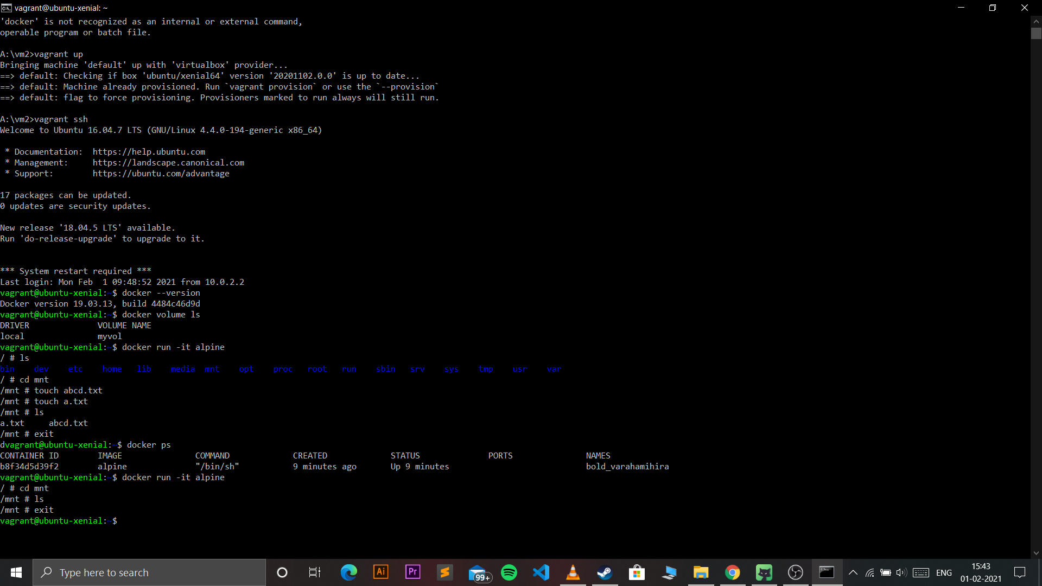

1. Creating and running volume in docker

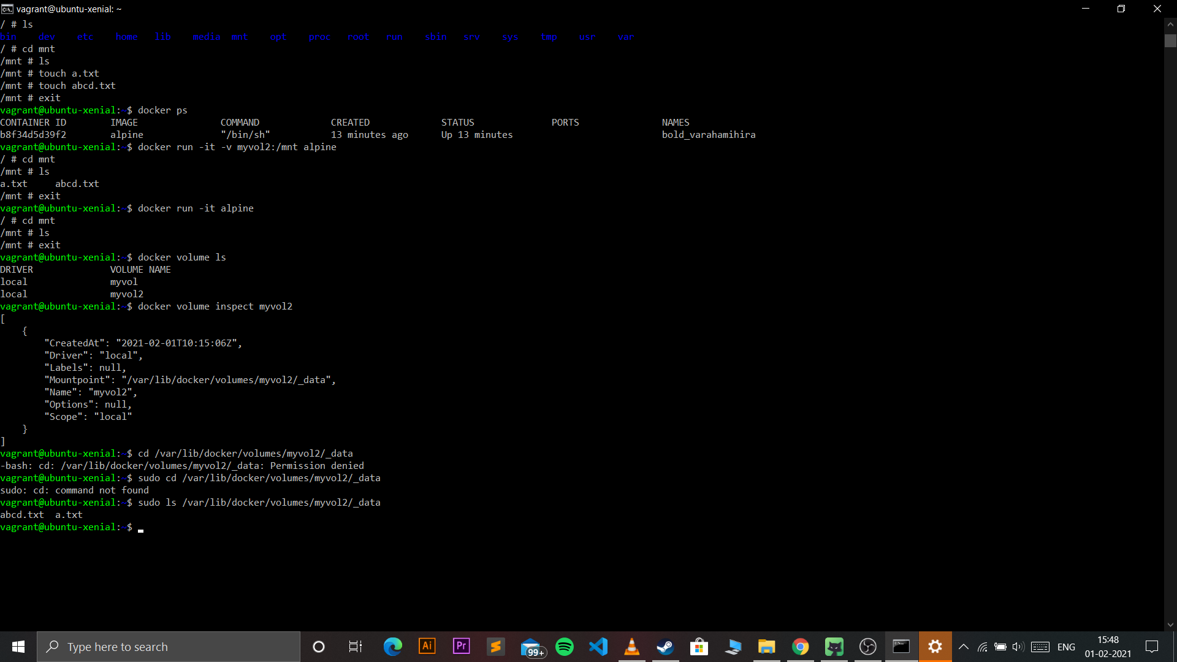

1. Creating volume c1

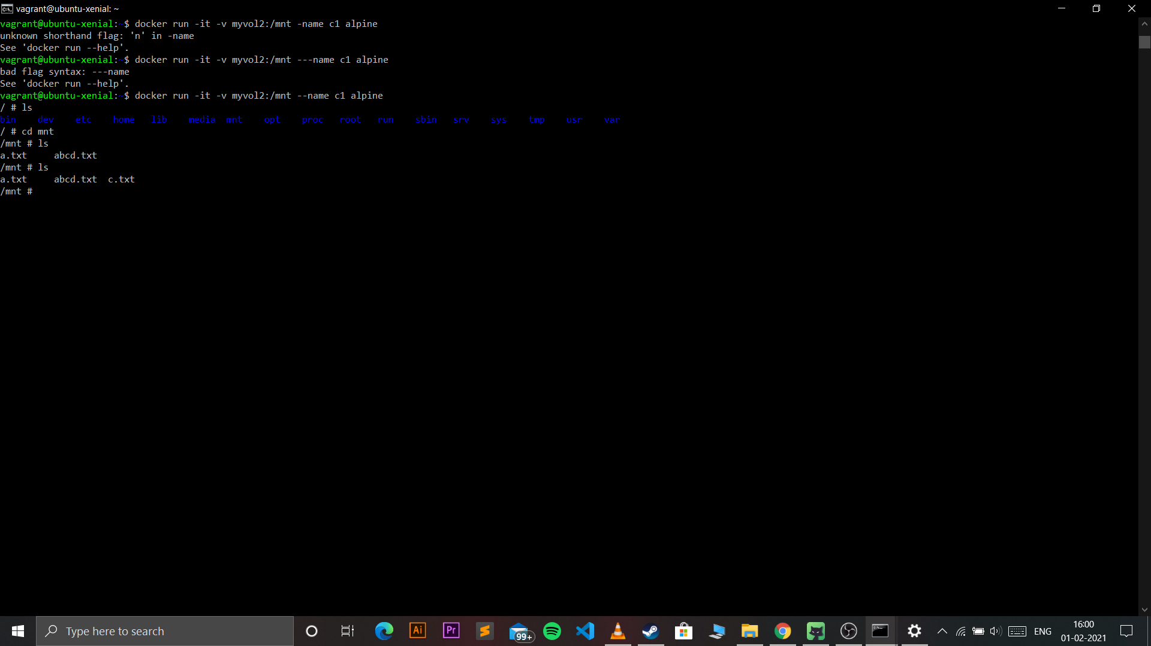

1. Creating volume c2 and seeing the files created in another volume exists there

